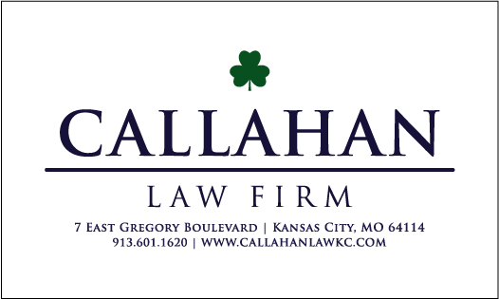
222 W. Gregory Blvd., Ste. 210, Kansas City, MO 64114 | 816-822-4041 | www.CallahanLawKC.com

General Information
Welcome to the Callahan Law Firm, we provide our clients with this General Information Sheet to provide some basic information to give our clients and idea what to expect during our representation.

Case Updates
Your attorneys at Callahan Law will contact you about all material updates on your case. This would include any offers that are extended from Plaintiff, and approval before any decision are made on your case. Sometimes there can be long periods of time where nothing substantial happens on your case and we are just appearing at court and continuing the case or filing responses to pleadings or motions filed by opposing counsel. This is especially the case if you are wanting us to buy you additional time before making a settlement offer.
We do not typically reach out to our clients with updates after a hearing on their case, but you are more than welcome to reach out and we will provide you with the next court date. Most of the hearings on these cases involve us asking for a continuance and the judge stating the new date.
The courts in Missouri and Kansas also make this information publicly available online.

Additional Resources
To learn more about Callahan Law Firm, check out our website.
- Website: https://www.callahanlawkc.com/
- Frequently Asked Questions: https://www.callahanlawkc.com/faqs/
- Blog Posts: https://www.callahanlawkc.com/blog/
Both Missouri and Kansas provide public access to the court records online, links below.
- Missouri Case.net: https://www.courts.mo.gov/cnet/welcome.do
- Kansas Court Public Access: https://prodportal.kscourts.org/prodportal
- Johnson County Court Public Records: https://public.jococourts.org

