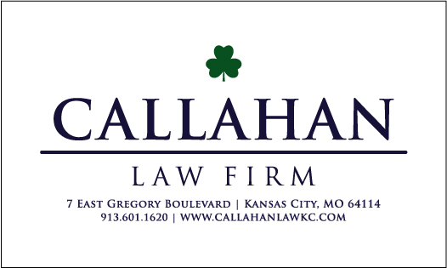

CREDIT REPORT AUTHORIZATION FORM

By my signature below I, {clientFirstName} {clientLastName} authorize the Callahan Law Firm, LLC to obtain my consumer reports from the Transunion, Equifax, and Experian credit reporting agencies (the “CRAs”) for the limited purposes of reviewing for accuracy and assisting with disputes to both the CRAs and any creditors reporting thereon. The Callahan Law Firm, LLC will not share my information with any third party for any purposes, unless I directly consent to doing so. There is no charge for this service, and the signing of this document creates no attorney/client relationship between myself and the Callahan Law Firm, LLC.

This authorization shall remain valid for one year after the date signed below.

Date Signature

INFORMATION REQUIRED:

{clientFirstName} {clientMiddleName} {clientLastName}
Name
{dob} |  | {SSN}
Date of Birth |  | SSN
{cellPhone} |  | {email}
Phone Number (with area code) |  | Email Address:
{homeAddress} |  | {homeCity}, {homeState} {homeZip}
Street Address |  | City | State | Zip

CONSUMER DISPUTE DISCLOSURE
- By my signature below I, {clientFirstName} {clientLastName} request that the Callahan Law Firm, LLC assist me with the preparation and mailing of consumer dispute letter(s) so that I may exercise my federal rights.

- I agree to reimburse the Callahan Law Firm, LLC for any out-of-pocket expenses incurred related to the mailing of consumer disputes on my behalf for mailing my disputes (such as postage and envelopes).

- I further understand that the Callahan Law Firm, LLC is not charging me any attorney’s fees for assisting me with the preparation and mailing of any consumer dispute(s) aside from said actual costs and expenses referenced in paragraph 1 above.

- I understand that the Callahan Law Firm, LLC does has not, and does not, make any representation that any type of dispute made as to anything on my credit report(s) will in any way improve or impact my credit rating.

Date Signature

